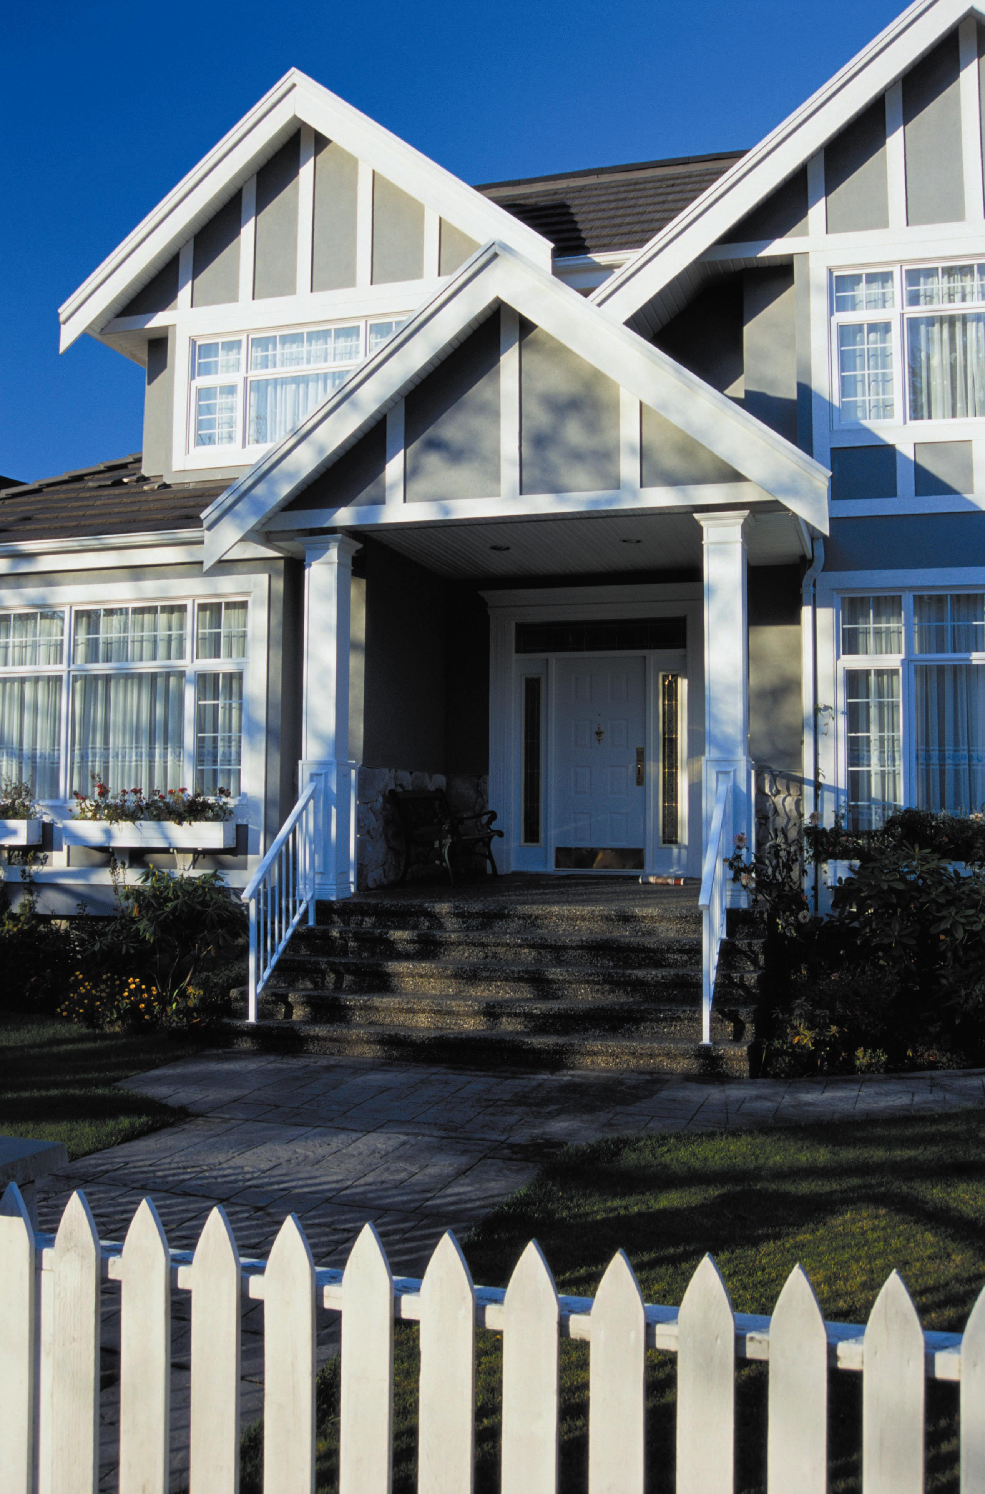
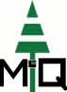
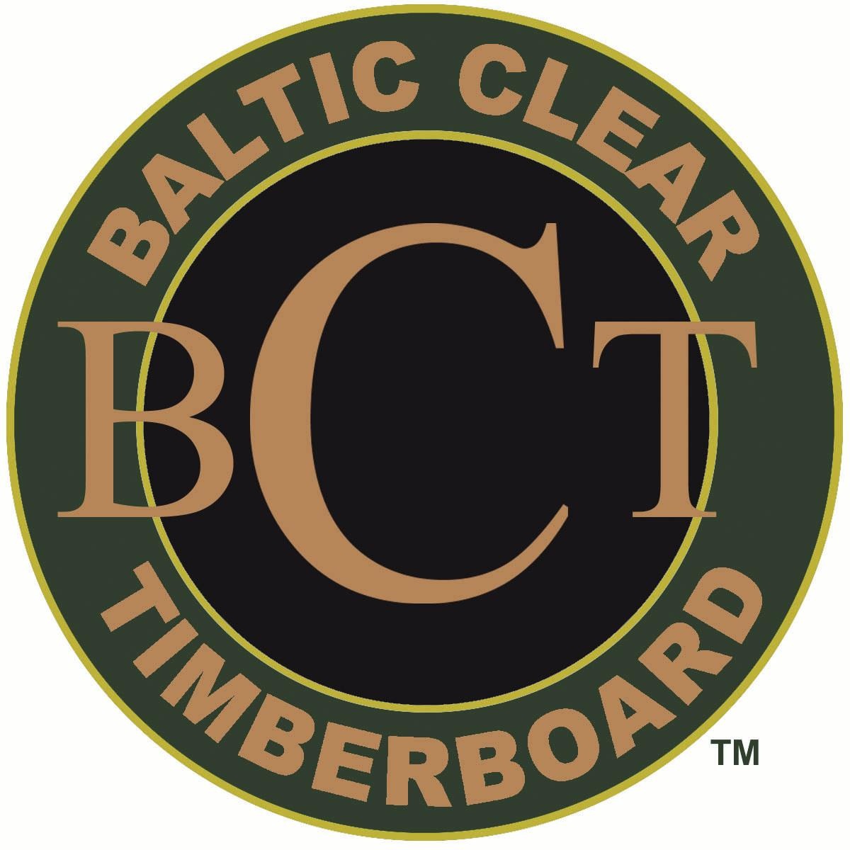
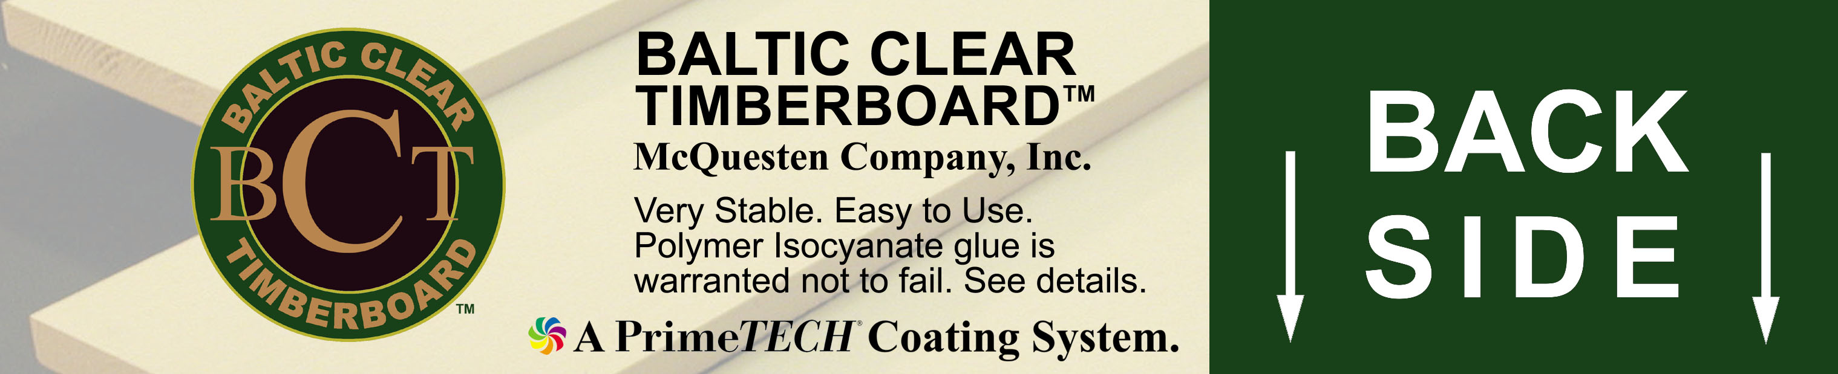

Features and Benefits

- Fingerjointed, edge-glued, all 16' Trim Boards

- Narrow Lamellas from mature timbers produce stable, straight boards

- PrimeTECH® Supercoat® System - the best in the industry

- 2 coats - one coat oil, one coat latex - optimal system

- 7 - year coating warranty upon installation

- 25 - year warranty after application of topcoat

- High-end pine, Pinus Sylvestris, proven in the Northeast

- Extremely durable glue warranted not to fail; even at water table

- Warranty includes material, labor, re-painting, and disposal of old material.
YES, you read that right
N. Billerica, MA (800) 752-0129
Manchester, CT (800) 468-8220
Milton, VT (800) 955-2677
Portland, ME (800) 888-0227

Available in New England only from

McQuesten Company

Visit: www.GoPrimeTECH.com
Call: (800) 458-5775

Finger-Jointed Clear
Pine So Exceptional
It's Guaranteed……
Labor Included!

