



Britton Lumber Company

Primed Finger Jointed Eastern White Pine

Why PrimeTECH Works
PrimeTECH-PremiumHide™ Oil Primer

PrimeTECH is a combination of high quality coatings and painting craftsmanship applied in a factory controlled environment to create low-maintenance superior siding and trim. Upon application of the proper finish coat over the PrimeTECH system, your coating will last two to three times longer than simply painting over bare wood. PrimeTECH is a preferred choice for builders because they count on the same quality and service on every order. Builders and homeowners know that if PrimeTECH is ordered, then the correct coating system will be used on a quality substrate. By contrast, wood that is merely “primed” can come in a variety of quality levels, service, and packaging that provides a result that can dramatically vary from order to order. PrimeTECH takes the guesswork out of choosing the right coating for the job.

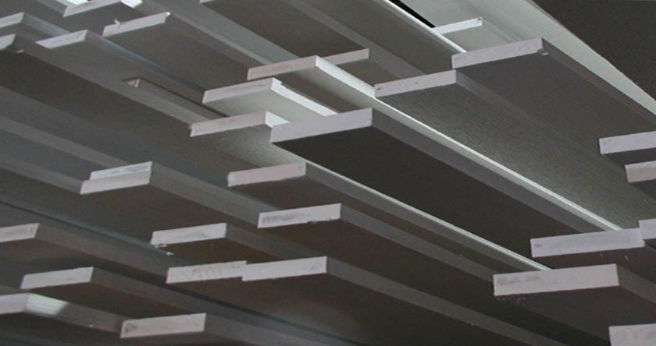
PrimeTECH 280

PrimeTECH 280 uses Cabot PrimeTECH -PremiumHide™, made exclusively for the PrimeTECH system. PrimeTECH -PremiumHide is an oil-based primer with considerable additional titanium dioxide added for maximum opacity and durability. It is designed for both excellent hiding and to allow for a variety of topcoat color choices. PrimeTECH -PremiumHide is an oil-based product with a very smooth finish and therefore, it resists grain raising, resin staining, sticking boards (also known as blocking) in hot weather, and provides a smoother, better-looking finish.
Boards are individually air-dried for best curing.

Customer Responsibility


1. You must apply a finish coat after installation to ensure your satisfaction with the final product and activate the warranty. PrimeTECH requires a field coat on all coated products. A field coat should be applied within four months. Topcoat should be a 100% acrylic latex paint or stain. For a 15-year
warranty from Cabot, apply two coats of Cabot “The Finish” 100% Acrylic House Paint with Teflon™ reinforcement. This coating has an “eggshell” finish for improved durability and washability.

2. If the product is not to your satisfaction, DO NOT INSTALL IT, we cannot be responsible for defects once it is installed. If you find defects, we will take back any uninstalled pieces to our factory to fix and return to you.
3. The product must be kept dry and above ground before being installed. The packaging included with the shipment of the wood is generally not sufficient by itself for outdoor jobsite storage. We recommend storing the product inside like any finished product.

4. If the surface over which the boards will be installed is wet (15% or more moisture) when you install, you may experience some staining from the resins in the wood. Always test the moisture behind the wood before installation. Moisture meters can be purchased through PrimeTECH at (800) 458-5775. One prevented problem will pay for the moisture meter many times over.

5. There is no guarantee, implied or otherwise, against knot “bleed-through” nor resin staining. We use an excellent method of applying standard technology in response to a natural and unpredictable phenomenon.

Britton Lumber
(800) 343-5300
Visit: www.GoPrimeTECH.com
Call: (800) 458-5775

