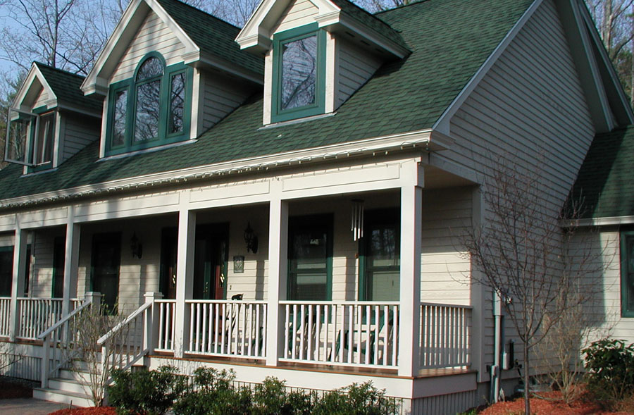
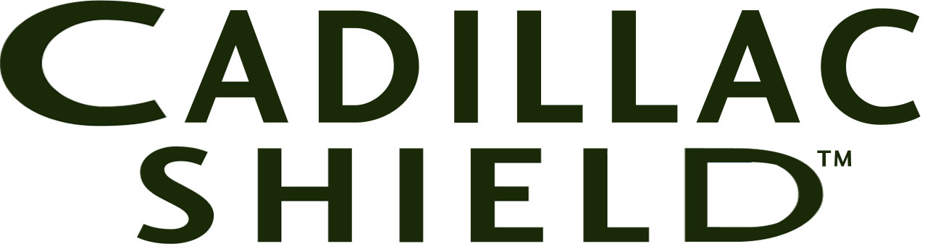

MADE IN MAINE

Cadillac Shield™ from Crobb Box Company is now available to you through your lumberyard. Cadillac Shield is a primed Eastern White Pine Clapboard available in Premium, Finish, and D&Better Select grades. Knots are sealed on the smooth face prior to priming. You may, however, use the rough face for a rustic look. Nothing compares to the stability and longevity of Eastern White Pine in Maine. Cadillac Shield delivers the best performance in a Pine Clapboard thanks to a great substrate and a great coating system from PrimeTECH.® Churchill Coatings of Maine creates PrimeTECH for Cadillac Shield using a proprietary oil primer formula made by Cabot. The result is a durable heavy primer made to last. A 15-year warranty is available from Cabot after applying Cabot acrylic topcoats such as The Finish™.

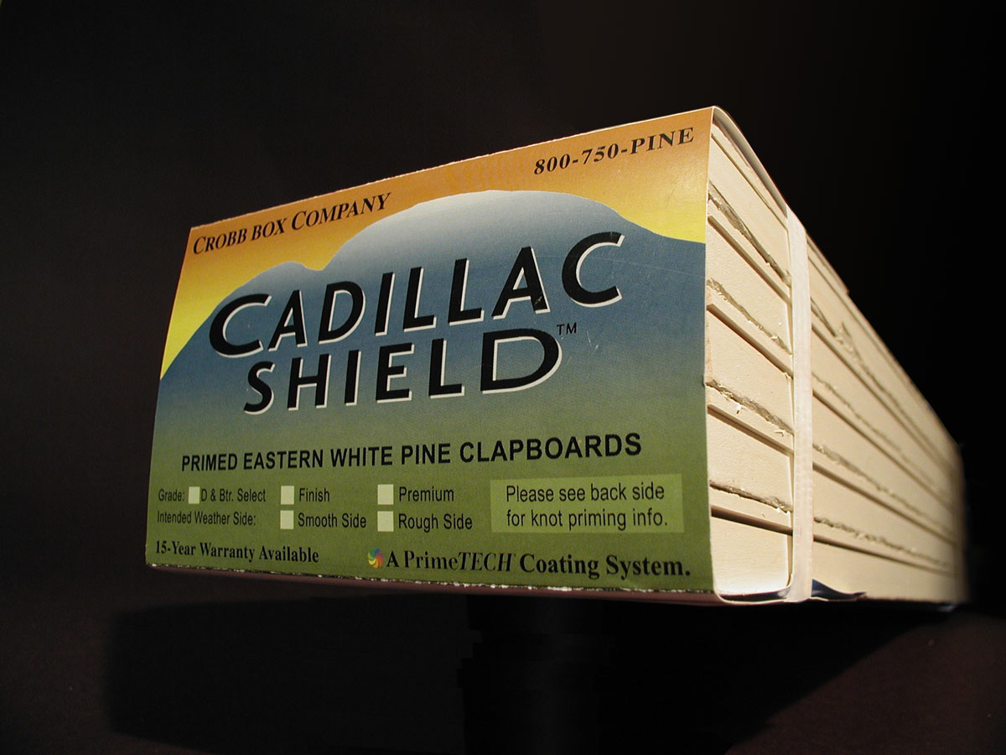

Eastern White Pine

Clapboard Siding

- Locally Available
- Factory Finished by Churchill Coatings of Maine.
- One coat of PrimeTECH® PremiumHide® Oil Primer made by Cabot.
- Use either smooth or rough face exposure.
- Topcoat with exterior coatings from Cabot for long-term warranties. See warranty for details.
CROBB BOX COMPANY

800-750-PINE

Visit us at: www.GoPrimeTECH.com
Or Call Toll Free: 800-457-5775

