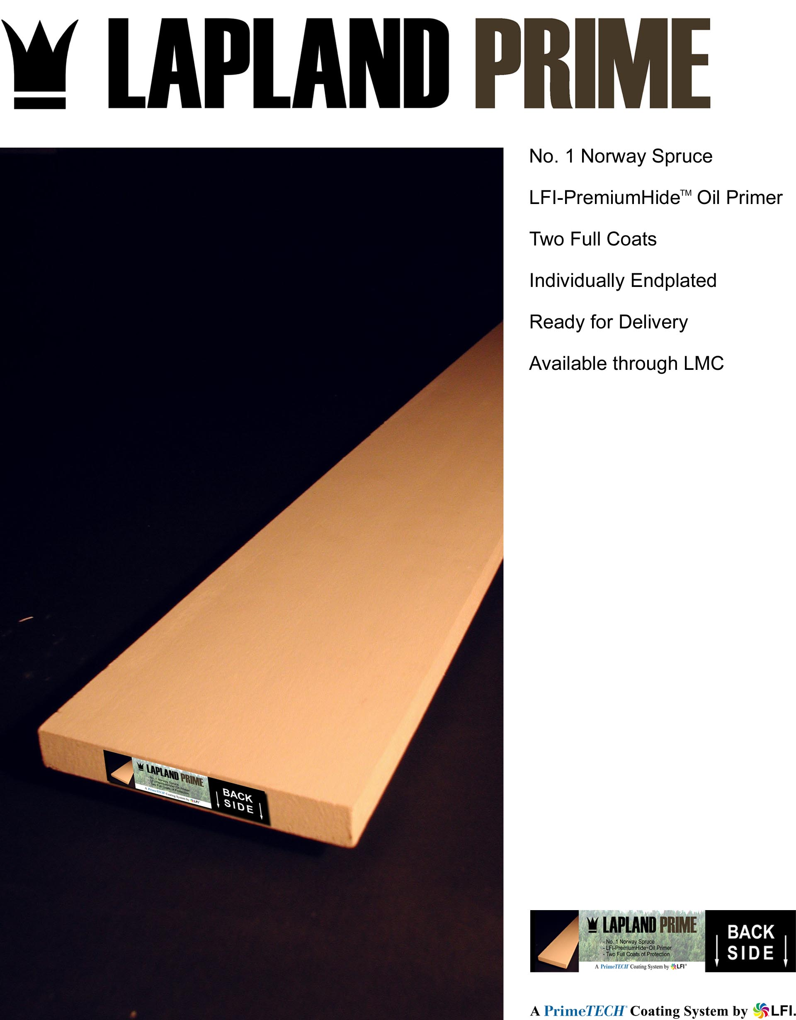

Visit us at: www.GoPrimeTECH.com
Or Call Toll Free: 800-457-5775

