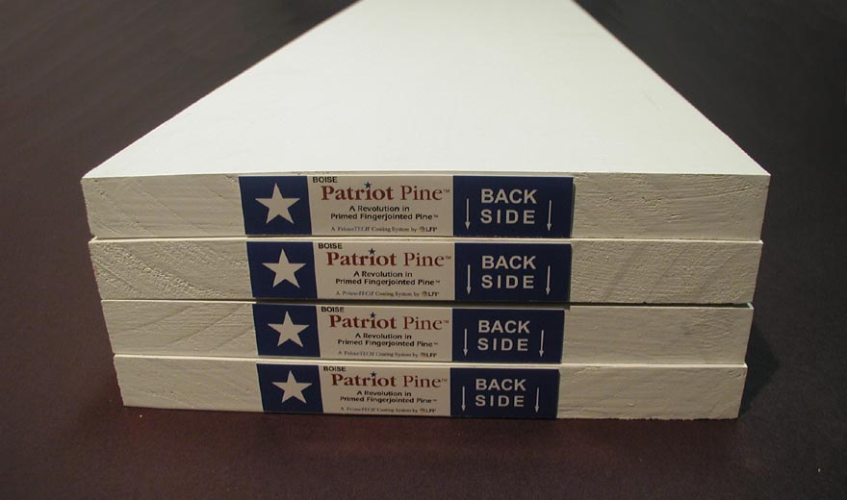
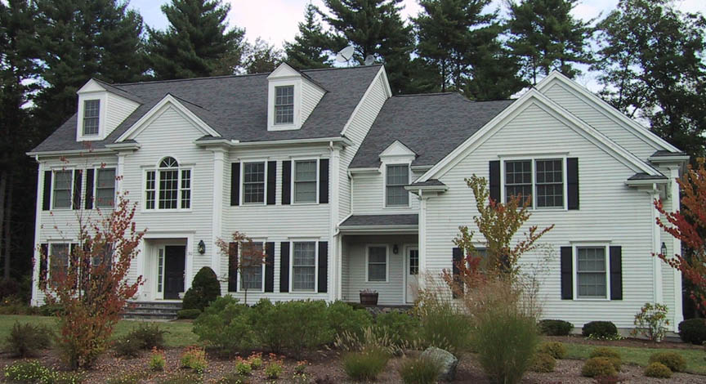


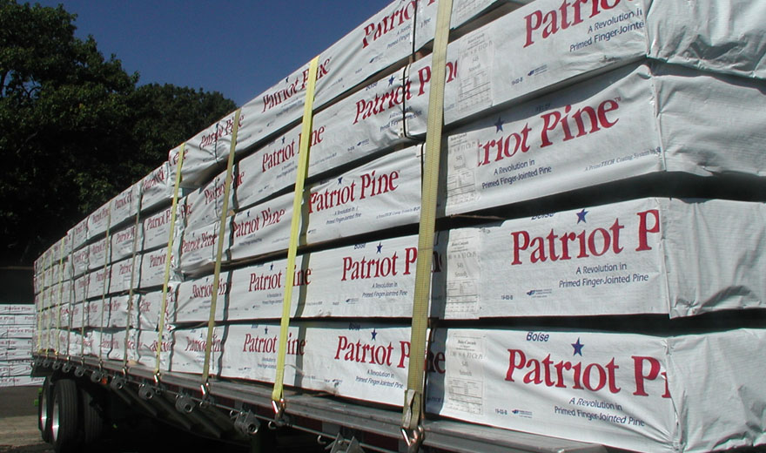
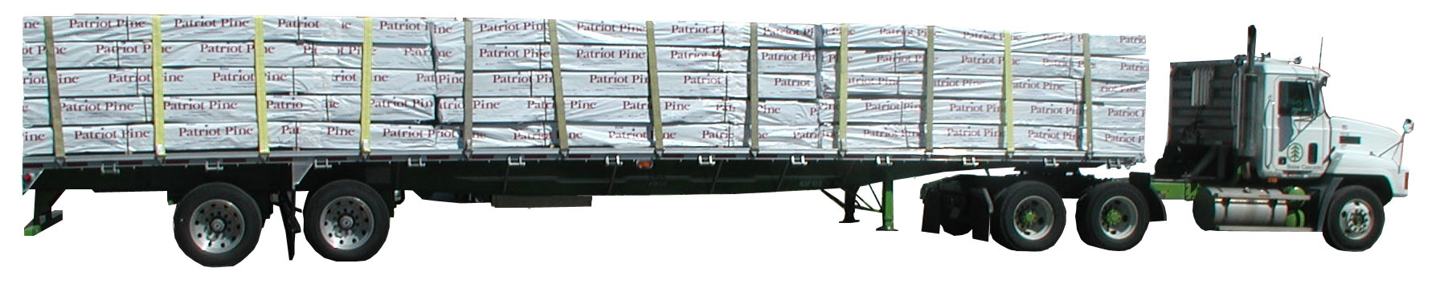


In Stock

Easily Identified

- Exceptional square-edge trim boards with bright white primer

- Proven reliability of supply

- Oil-based coating for smooth finish and solid appearance

- The most beautiful bright white oil-based primer available

- Easy name recognition

- Backed by Boise’s commitment to quality and service

- Solid steady growth of program ensures long-term availability

- All 16-foot lengths

- 1,000 foot units for more cost effective inventory

- Premium-grade universal primer allows for any type of topcoat—latex or oil-based

Beautiful Results

Ready to Ship

“A Revolution in Primed Fingerjointed Pine”
Visit us at: www.GoPrimeTECH.com
Or Call: 800-458-5775

1-877-462-6473

