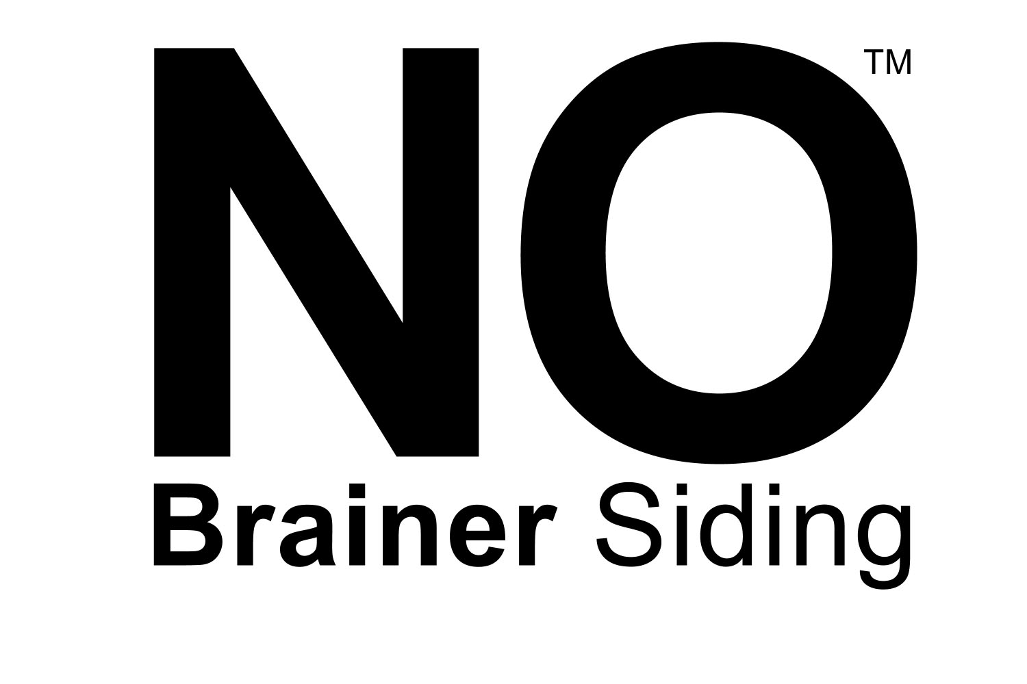

CVG Cedar Bevel Siding with 2 Coats of Any Color

Delivered in 10 Business Days

- One phone call brings the lumber and the coating
- Solid CVG Cedar 3’ – 20’ random length
- 15-year warranty after required field coat / extendible to 30 years
- Highest grade of cedar produced in the world
- PrimeTECH® 650 2-Coat system for longest life
- Quick turn-around time

“Any other siding with any other coating system
is a step down. This one is a no-brainer”

Call us at Churchill Coatings. 800-458-5775
Order from your lumberyard.

This is also your order form. (Simple, isn’t it?)

Company: ________________________ Feet: _________________________
in lineal feet in square feet

Name: ________________________ Color: _________________________

_________________________

PO: ________________________

Face: Rough Side Smooth Side

FAX TO: Price Quoted: __________________

508-839-9239

Visit us at: www.GoPrimeTECH.com
Or Call: 800-458-5775
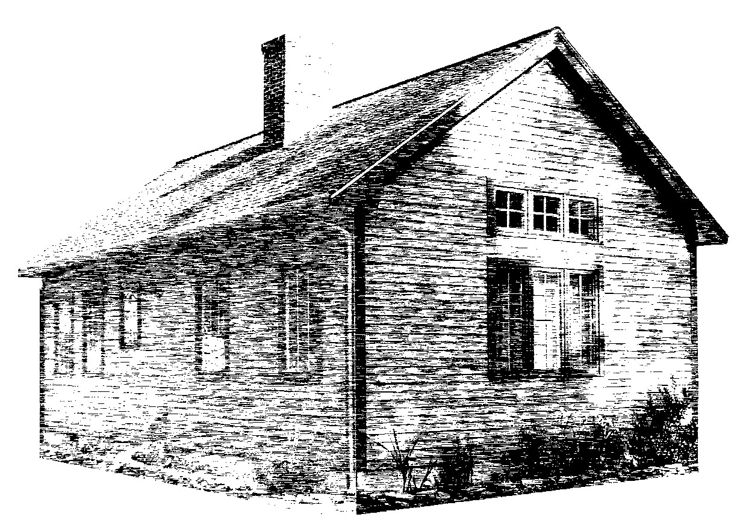

The Story of No Brainer™ Siding

We made a surprising discovery when we sent our team of experts into the field to look at siding. Well, shock of all shocks, it appeared that vinyl siding was trying to look like wood siding. “What the? Why would anyone bother to imitate wood without improving it?” our team of experts asked themselves. Maybe, they thought, people want something that almost looks like wood if you’re far enough away? No sooner had they patted themselves on the back for figuring this one out when one of them interrupted, “maybe it’s because they think it’s less maintenance?” Well that took the rattle out of their windstorm in a hurry. But it didn’t stop their scientific minds from brainstorming a new idea. “If everyone likes wood but doesn’t like maintenance, then let’s produce wood siding that’s as low maintenance as vinyl. Hmm,” they continued to wonder, “if we could get real wood siding to imitate vinyl, that’d be neat.” They all pondered this for a moment. Sure enough, from far away, say several hundred yards, wood does look a lot like vinyl. And if the maintenance is about the same… “Well shoot,” chimed in one particularly astute ponderer, “that would be a no-brainer.” And thus, No Brainer™ Siding was born, a clapboard with all of the best ingredients to make it so good, it will last for decades and make you wonder why anyone thought we should create an alternative in the first place. What are its attributes, you ask?

One. Like vinyl, it looks just like wood. (Partly because it is wood, and partly because we don’t know why but even if you’re playing ball with your kids in the yard, it still looks like wood.)

Two. It’s not just any wood. It’s ½ x 6 CVG-Clear Vertical Grain Western Red Cedar, the highest grade level of the longest lasting, most respected siding on the planet.

Three. The coating system is the secret ingredient to making it low maintenance. It’s got PrimeTECH® 650 from Churchill Coatings using oil primer from Cabot and latex topcoat from Cabot. (Okay, it’s not a secret anymore.)

Four. Boy, does it last. After the required final coat is applied upon installation, the warranty is 15 years and extends to 30 years after another coating in year 15. So let’s say you side your house at age 40. Then you’ve painted it one more time by the age of 70. And that whole time, you’ve got beautiful wood siding on your home. Is that low maintenance enough?

Five. It’s one phone call. If you’re a builder, order from your lumberyard. Otherwise, Call Churchill Coatings toll free at 800-458-5775. That gets you the wood, the coating system, and delivery to the lumberyard in 10 business days. Have we made this simple or what?

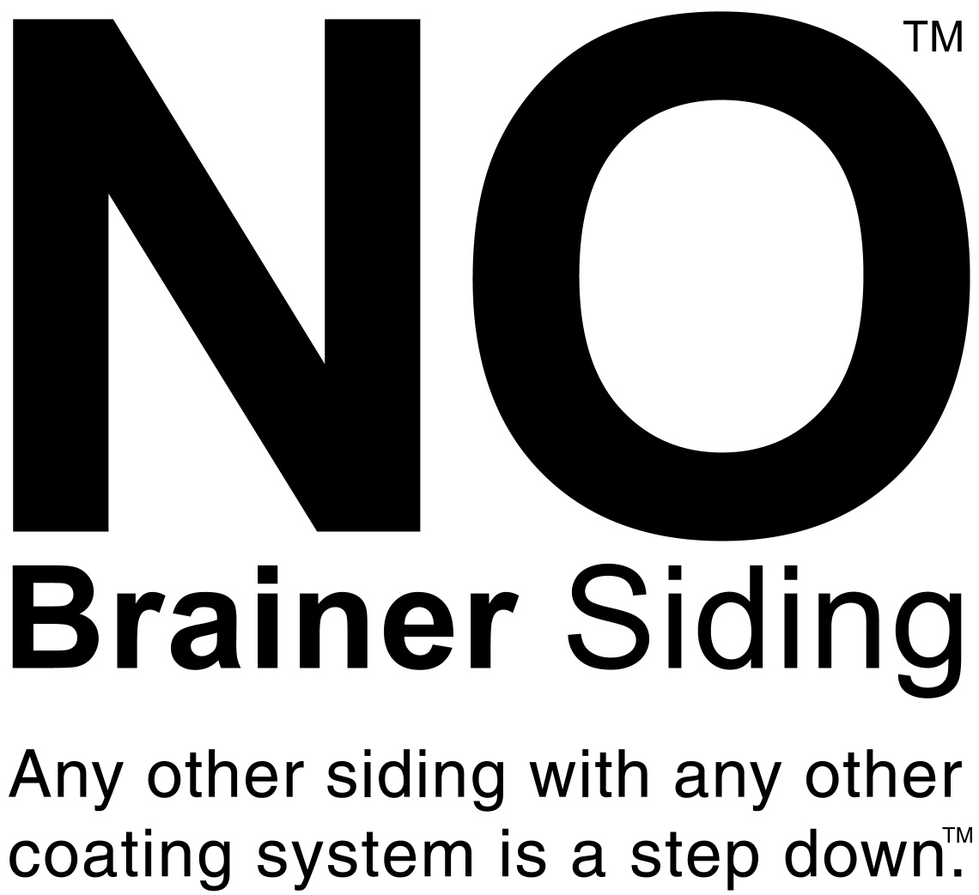

Here’s the order form. Fax it to 508-839-9239:

Name:_____________________ Company:_________________ PO:_____________
Feet:_______________ in lineal ft. in square ft. Face: Rough Side Smooth Side

Color:____________________________________ Price quoted: ________________

Visit us at: www.GoPrimeTECH.com
Or Call: 800-458-5775

