
Custom Tinted Oil Primer Field Guide

Why PrimeTECH® Works

PrimeTECH is a unique combination of high quality coatings and painting craftsmanship applied in a factory controlled environment to create low-maintenance superior siding and trim. Upon application of the proper finish coat over the PrimeTECH system, your coating will last two to three times longer than simply painting over bare wood. PrimeTECH is a preferred choice for builders because they count on the same quality and service on every order. Builders and homeowners know that if PrimeTECH is ordered, then the correct coating system will be used on a quality substrate. By contrast, wood that is merely “primed” can come in a variety of quality levels, service, and packaging that provides a result that can dramatically vary from order to order. PrimeTECH takes the guesswork out of choosing the right coating for the job.

PrimeTECH® 220 (One Coat, Any Color)

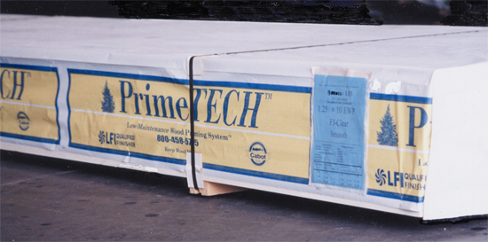
PrimeTECH 220 uses Cabot Factory Finish oil-based primer applied with the specifications of Cabot using the rigid methods of PrimeTECH. The advantage of this system is that it can be tinted to almost any color since it is made in a full line of tint bases. Tinted primer allows the topcoat to cover more easily in the field. Factory Finish primer is designed for adhesion, durability, and cedar-bleed resistance. Cabot Factory Finish is an oil-based product and therefore, resists grain raising, resin staining, and blocking boards.

Customer Responsibility

1. A field coat is required after installation. Saw cuts, end joints, nail heads, color matching, and any other minor imperfections are corrected with the final coating. A field coat should be applied within 90 days after installation. For a 15-year warranty from Cabot, apply two coats of Cabot “The Finish” 100% Acrylic House Paint with Teflon™ reinforcement.

2. If the product is not to your satisfaction, DO NOT INSTALL IT. We cannot be responsible for defects once it is installed. If you find defects, we will take back any uninstalled pieces to our factory to fix and return to you.

3. The product must be kept dry and above ground before being
installed. The packaging included with the shipment of the wood
is generally not sufficient by itself for outdoor jobsite storage.

Coated wood should never be stored outside until it is installed.

4. If the sheathing, or wood behind your siding and trim, is wet (15% or more moisture) when you install, you may experience tannin bleeding. Always test the moisture of the sheathing before installation. Moisture meters can be purchased through PrimeTECH at (800) 458-5775. One prevented problem will pay for the moisture meter many times over.

5. There is no guarantee, implied or otherwise, against tannin staining. It is a natural and unpredictable phenomenon that can occur on any wood siding or trim that contains tannin resins. Taking the above steps will help reduce the chances of its occurrence. Take extra precautions with light-colored houses such as white, yellow, linen, or light gray since tannin staining appears more easily on these colors.

