
Woodtones™ for Fiber-Cement Field Guide

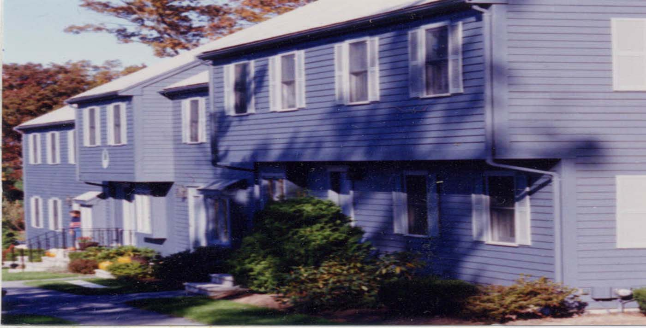
The PrimeTECH 630 process is an excellent system for exterior use because it is a finished system for cement. A quart is supplied for touch up of edges. This new coating is tough enough to resist scratching. It makes the cement look like wood with varying shades of the same color.

1) First Coat: Cabot Stain Collection base coat
4 wet mils of coating on face and edges
2) Second Coat: Cabot Stain Collection top coat,
4 wet mils of coating on the face and edges..

Benefit: Extremely tough finish that does not require a field coat. Gives cement a unique look of varying tones to make it look like wood. Blind nailed so nails do not show.

How to get a 12-year warranty: Install cement according to manufacture’s specifications and touch up the saw cuts.

Why PrimeTECH Works
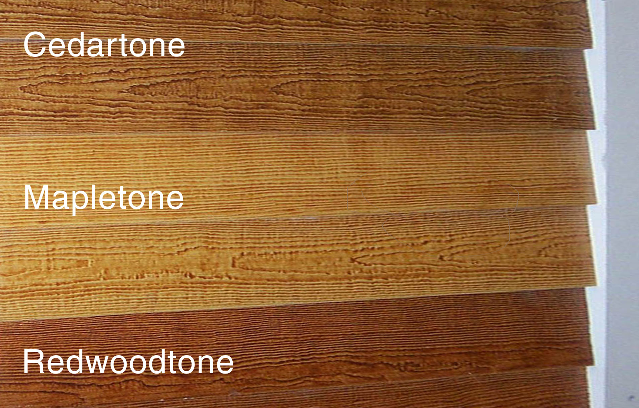

PrimeTECH is a unique combination of high quality coatings and painting craftsmanship applied in a factory controlled environment to create low-maintenance superior siding and trim. Upon application of the proper finish coat over the PrimeTECH system, your coating will last two to three times longer than simply painting over bare wood. PrimeTECH is a preferred choice for builders because of the consistency of quality and service on every order. Builders and homeowners know that if PrimeTECH is ordered, then the correct coating system will be used on a quality substrate. By contrast, wood that is merely “primed” can come in a variety of quality levels, service, and packaging that provides a result that can dramatically vary from order to order. PrimeTECH takes the guesswork out of choosing the right coating for the job.

Customer Responsibility

1. No field coat is required after installation. Touch up saw cuts with material provide. Follow cement manufacture’s installation instructions. Protect finish from abrasion and other abuse during installation process.

2. If the product is not to your satisfaction, DO NOT INSTALL IT. We cannot be responsible for defects once it is installed. If you find defects, we will take back any uninstalled pieces to our factory to fix and return to you.

3. The product must be kept dry and above ground before being
installed. The packaging included with the shipment of the cement is generally not sufficient by itself for outdoor jobsite storage. Coated wood should never be stored outside until it is installed.
4. If the sheathing, or wood behind your siding and trim, is wet (15% or more moisture) when you install you may have moisture problems. Always test the moisture of the sheathing before installation. Moisture meters can be purchased through PrimeTECH at (800) 458-5775. One prevented problem will pay for the moisture meter many times over.

