
Acrylic top coat over primed material Field Guide

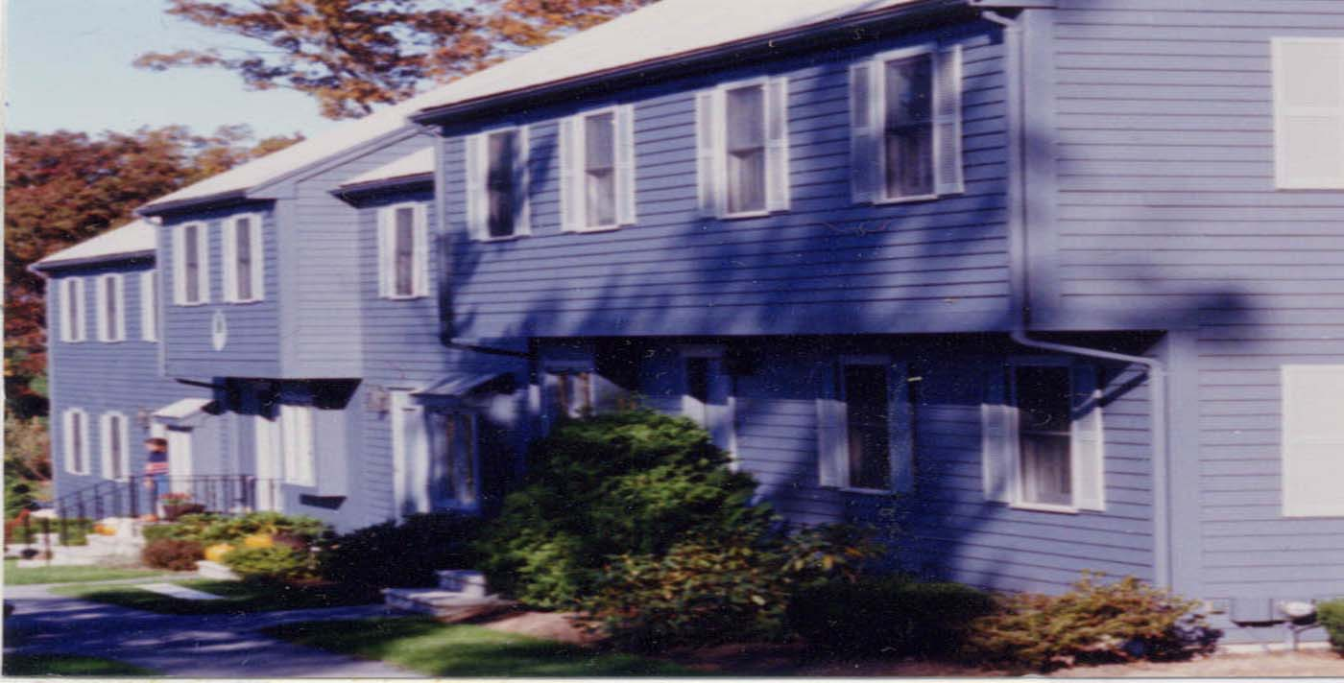
The PrimeTECH 655 process is an excellent second coat process for exterior use because it withstands the weather virtually indefinitely until the field coat can be applied and it covers much better than one oil-based primer coat for easier field coating after siding is installed. PrimeTECH 655 is our most popular two-coat priming system when high performance is absolutely necessary.

1) First Coat: Cabot Stain-Blocking Oil-Based Primer,
6 wet mils of coating on all sides (supplied by customer).
2) Second Coat: Cabot Factory Finish Acrylic Topcoat,
6 wet mils of coating on the front face and two sides.

Benefit: Excellent choice for cedar and other siding types due to superior stain-blocking and exceptional hiding when quality, coverage, and performance is required.

How to get a 15-year warranty: For the warranty, apply one coat of Cabot brand's "The Finish" 100% acrylic latex overcoat after installation of lumber.

Why PrimeTECH Works
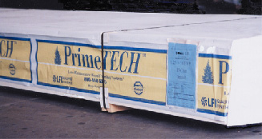

PrimeTECH is a unique combination of high quality coatings and painting craftsmanship applied in a factory controlled environment to create low-maintenance superior siding and trim. Upon application of the proper finish coat over the PrimeTECH system, your coating will last two to three times longer than simply painting over bare wood. PrimeTECH is a preferred choice for builders because of the consistency of quality and service on every order. Builders and homeowners know that if PrimeTECH is ordered, then the correct coating system will be used on a quality substrate. By contrast, wood that is merely “primed” can come in a variety of quality levels, service, and packaging that provides a result that can dramatically vary from order to order. PrimeTECH takes the guesswork out of choosing the right coating for the job.

Customer Responsibility

1. A field coat is required after installation. Saw cuts, butt joints, nail heads, color matching, and any other minor imperfections are corrected with the final coating. A field coat should be applied sometime within the first year after installation. For a 15-year warranty from Cabot, apply one coat of Cabot “The Finish” 100% Acrylic House Paint with Teflon™.

2. If the product is not to your satisfaction, DO NOT INSTALL IT. We cannot be responsible for defects once it is installed. If you find defects, we will take back any uninstalled pieces to our factory to fix and return to you.

3. The product must be kept dry and above ground before being
installed. The packaging included with the shipment of the wood
is generally not sufficient by itself for outdoor jobsite storage. Coated wood should never be stored outside until it is installed.
4. If the sheathing, or wood behind your siding and trim, is wet (15% or more moisture) when you install, you may experience tannin bleeding. Always test the moisture of the sheathing before installation. Moisture meters can be purchased through PrimeTECH at (800) 458-5775. One prevented problem will pay for the moisture meter many times over.

5. There is no guarantee, implied or otherwise, against tannin staining. It is a natural and unpredictable phenomenon that can occur on any wood siding or trim that contains tannin resins. Taking the above steps will help reduce the chances of their occurrence.

6. With very light colors such as white, yellow, linen, light gray, etc., we recommend three factory coats (one primer and two topcoats) to ensure that one additional coat after installation will provide adequate coverage.

