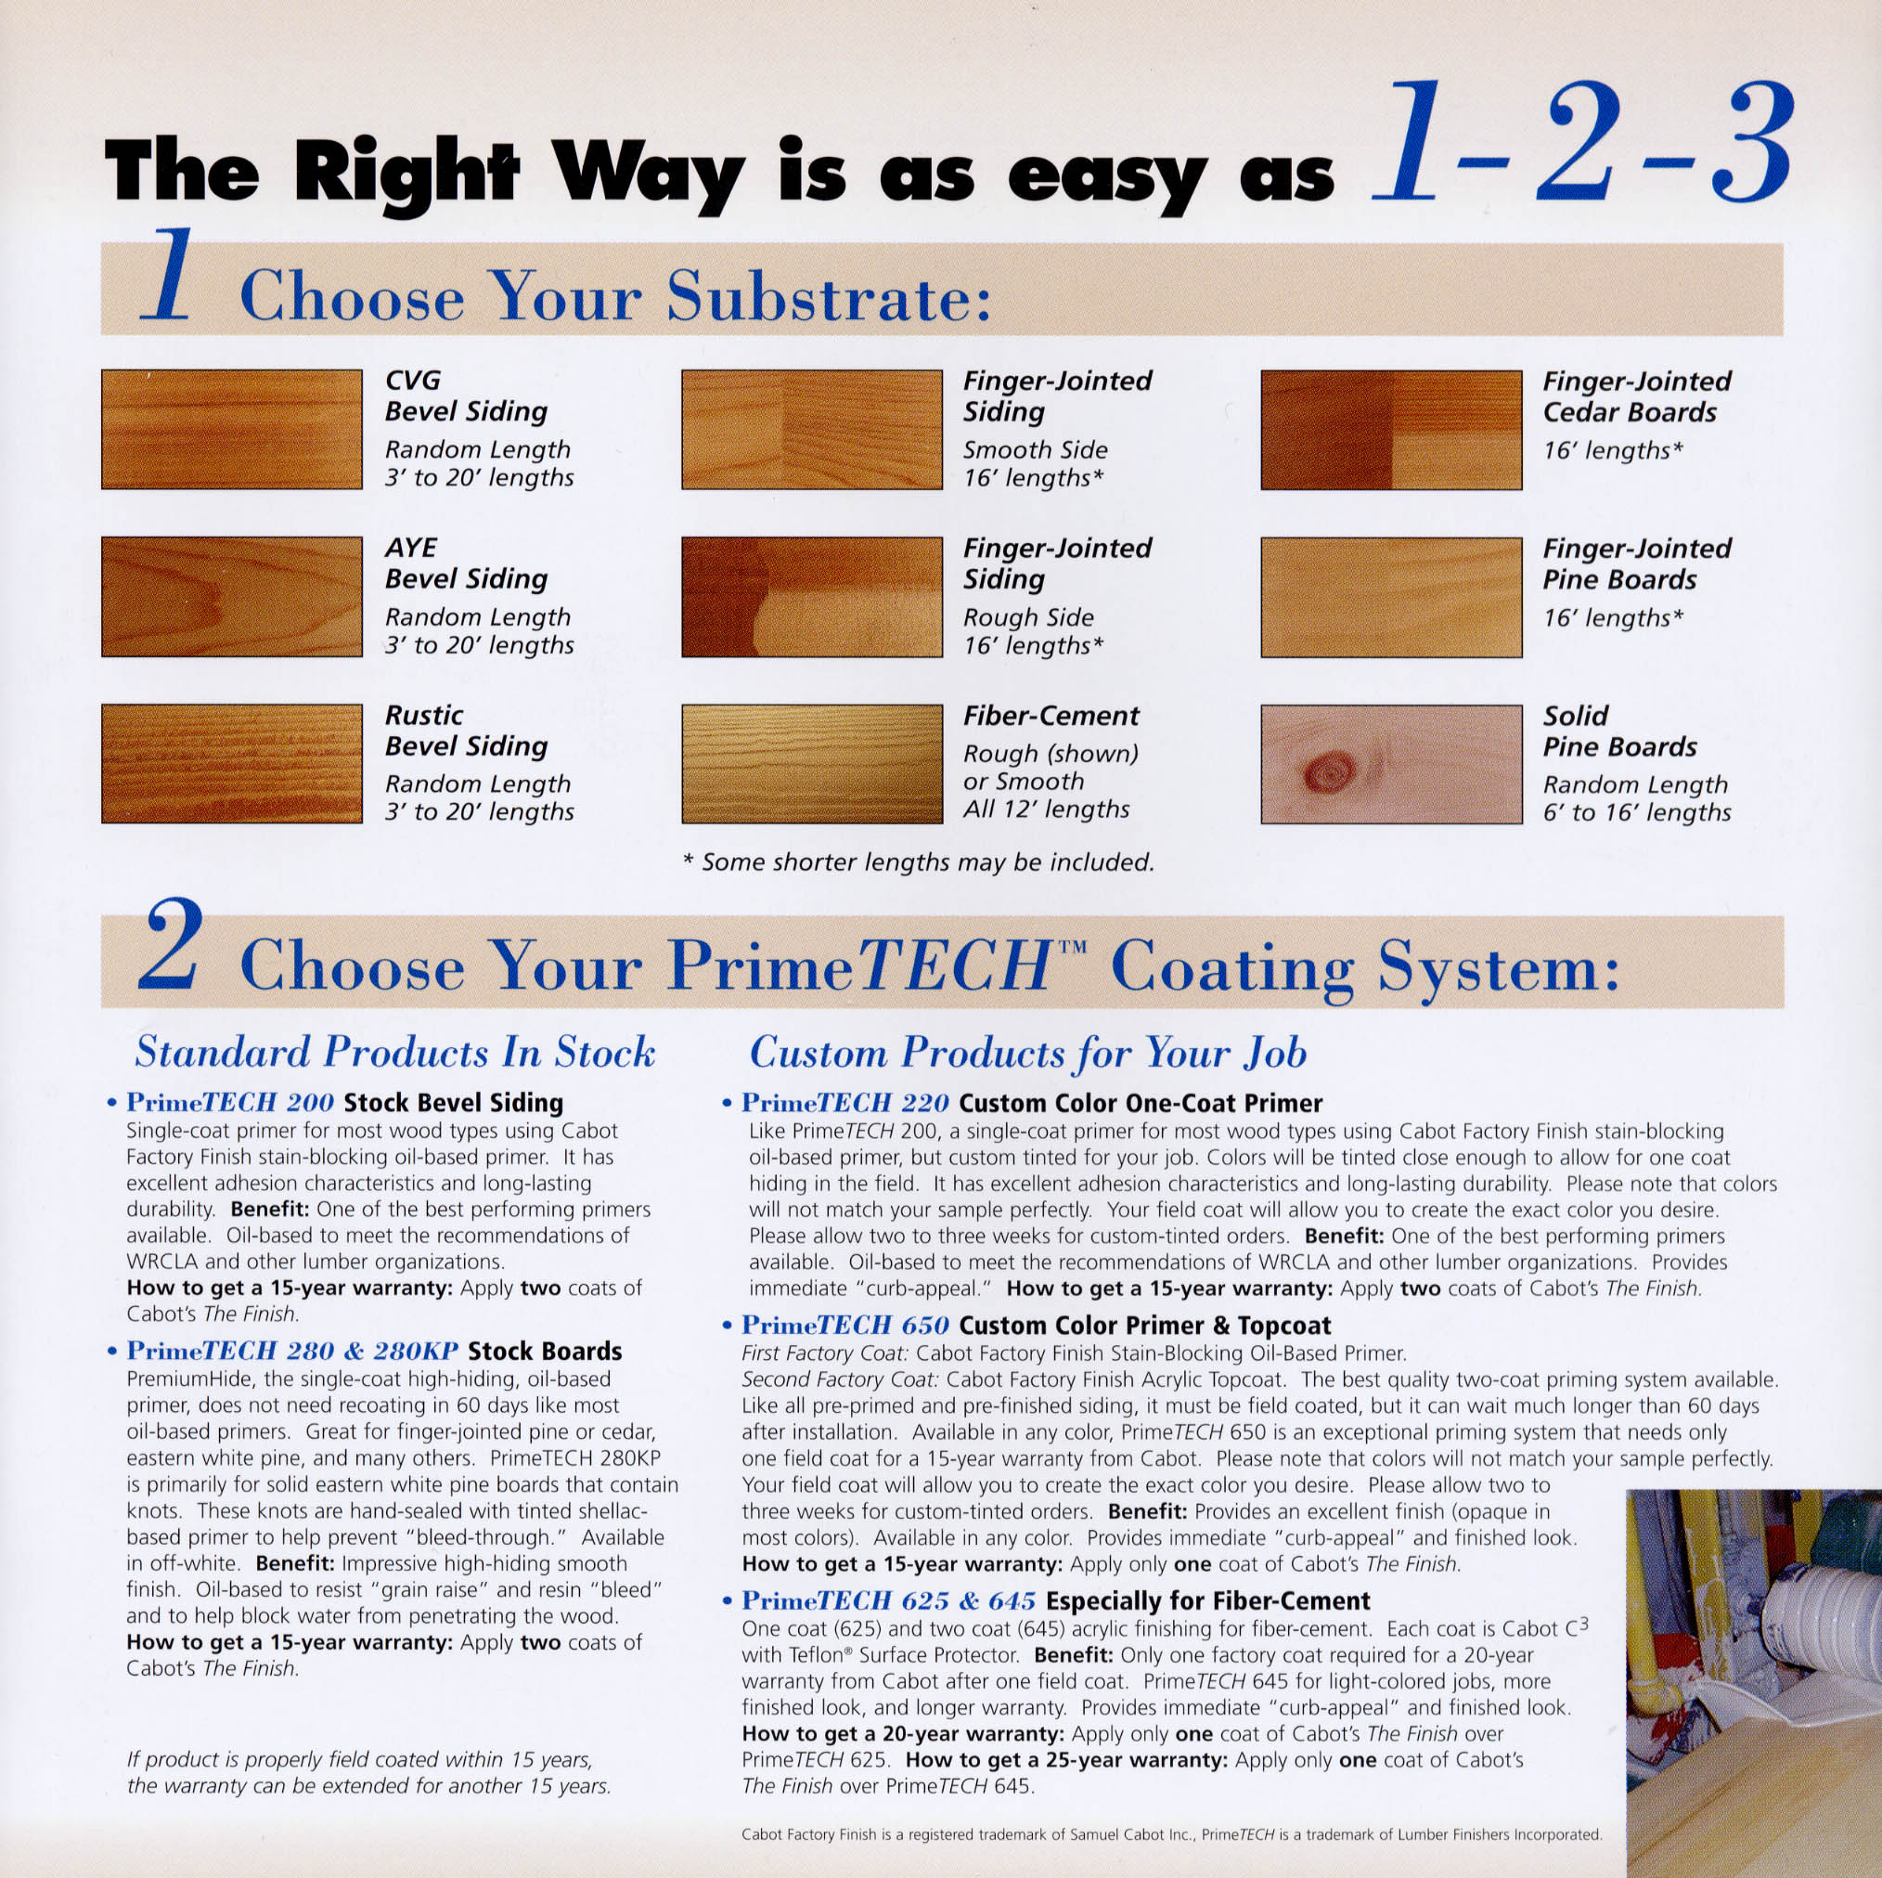

Visit us at www.GoPrimeTECH.com
Call us: (800) 458-5775



Visit us at www.GoPrimeTECH.com
Call us: (800) 458-5775

