

Guide to Extractive Bleeding Page 1
By Fred Churchill

As a result of numerous inquiries from our customers, we offer the following information about extractive bleeding as it relates to exterior wood siding. While the phenomenon is infrequent compared with the vast quantity of siding that we have primed over the years, we have seen hundreds of cases and have learned a great deal about the condition from this experience.

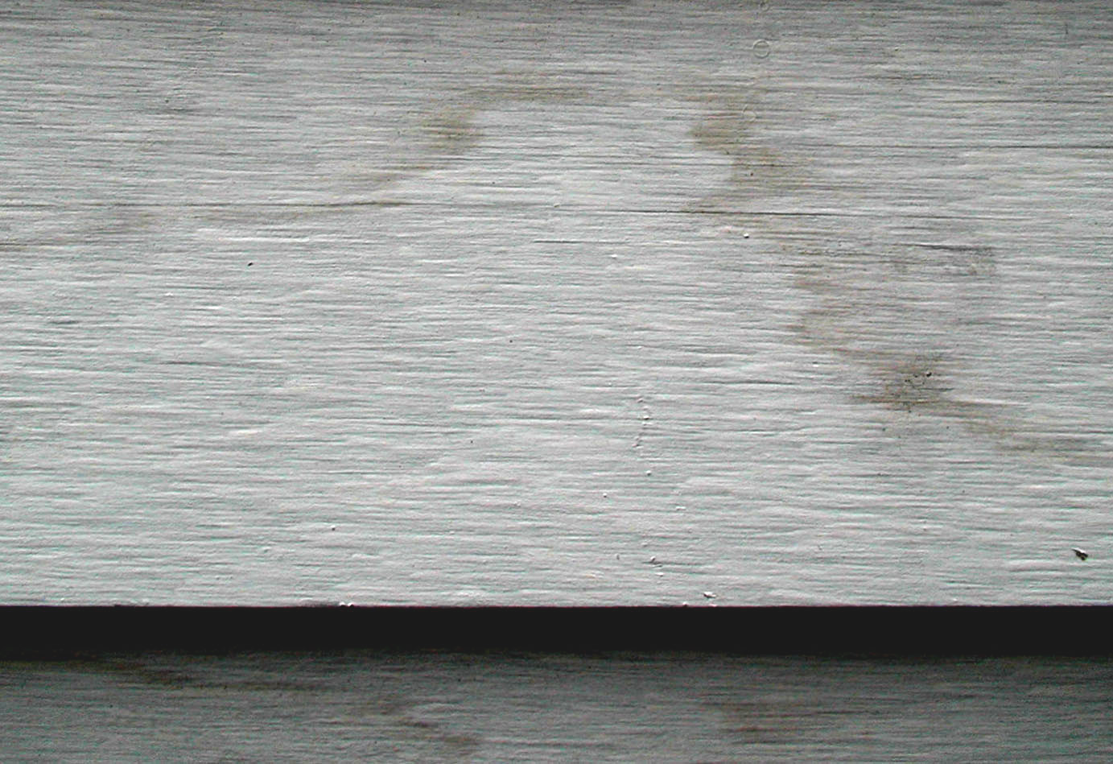
Cedar, Redwood, and other species have extractives in them. These give the wood their color and their decay resistance and are a natural part of the wood. Since wood extractives are water-soluble, when wood absorbs moisture, the moisture migrates to the surface and carries the extractives with it. The moisture evaporates and leaves the extractives on the surface as a stain or discoloration. Many primers are specifically designed to block extractive bleeding, but they are not always successful and manufacturers, as a rule, do not carry a warranty for this purpose. Extractive bleeding does not affect the integrity of the coating. It is only an issue of appearance.
Extractive bleeding appears as reddish water stains on the surface of the wood.

Tips for Avoiding Extractive Bleeding

1. Store wood before installation.
If stored outside - put a vapor barrier under wood, raise off the ground with room for air ventilation, and keep covered. If stored inside – put vapor barrier under wood and raise off ground – especially important when wood is on green concrete

2. Install over dry plywood, OSB, or other sheathing substrate.
Wood must be installed over dry substrate – less than 15% moisture content. When it rains, sheathing gathers moisture. Exterior housewrap does not prevent moisture from building up in sheathing. It can, in fact, slow the drying process. It is important to check the moisture level in the sheathing with meter before installing the siding.

3. Use construction techniques to prevent moisture from penetrating from the exterior.
Caulk all joints, hammer nails flush with the siding, do not over-nail, and, though it is not practical, avoid heavy rain and high humidity. Touch up cut ends of wood with oil primer before installation.

4. Allow moisture inside the building to ventilate.
Allow ventilation from inside the house to outside – ridge vents, etc. Avoid excessive moisture in building from an over-functioning humidity system (check settings), from plaster that is drying in a sealed house, or other sources.

5. A rainscreen can be an effective reducer of trapped moisture.
A rainscreen is a layer of air between the sheathing and the siding. “Furring” out the siding and leaving gaps at the bottom and top of the siding to allow air flow is a great way to keep moisture from passing through the siding. Benjamin Obdyke makes a product called Home Slicker™ just for this purpose which works even better than wood strips because the air space is free of blockages.

What To Do If Extractive Bleeding Occurs

The most important thing to do is not act too quickly: observe carefully and test each step of the solution to make sure that it works as you expect.

1. Do not apply any topcoat.
Topcoats are usually latex and have no ability to stop extractives. In fact, the water in latex paints activates the stains and brings them once again to the surface of the coating.

Guide to Extractive Bleeding Page 2
By Fred Churchill

What To Do If Extractive Bleeding Occurs (Continued)

2. Wait and see if discoloration washes off when it rains.
Sometimes, if the stains are not “locked” into the coating, rain will carry them away over time.

3. Try washing the stains with a special cleaner like Cabot 8003 Wood Brightener.
Again, if the stains are not “locked” into the coating, they can be successfully washed off. Washing with a cleaner works much faster than waiting for rain.

4. If bleeding disappears with washing, wait a few days to make sure it does not return.
If the source of the moisture has not been abated, more discoloration might appear as additional extractives work their way to the surface, even after some have been washed away. At this point, it is a good idea to test the sheathing behind the siding for moisture. A “deep-prong” moisture meter will allow for reading the moisture level in the sheathing without removing the siding.

5. If discoloration does not return, paint a small “test area” with your selected topcoat and see if bleeding appears.
If this test area does not show signs of staining after a few days and especially after a heavy rain, then it is usually okay to topcoat the building as planned. Try to choose an area that previously show significant stains as this is probably an area that was particularly moist. If cedar bleed persists and will not wash off, wait until the bleeding stabilizes. Examine the bleeding areas over a period of time to see if they are getting worse or have stabilized.

6. For severe cases, once bleeding has stabilized, re-prime a small test area with a stain-blocking oil primer.
Tinting the prime coat color toward the finish color will help make topcoating easier. Wait a few days to ensure that this new prime coat stops continued bleeding. Again, choose an area that is particularly stained.

7. Apply topcoat to the test area before priming the whole affected area of the house.
For best durability, topcoat should be 100% acrylic latex paint or stain. Apply this topcoat over the test primer and wait again to see if any staining emerges.

8. If the stains do not reappear, the approach above that worked can be applied to the entire building.
Again, important to solving extractive bleeding problems is testing and observing. With proper care of your siding before installation and diligence afterwards, your siding will stand the test of time and provide a low-maintenance beautiful choice for the outside of your home.

This information is designed to help you understand and work with extractive bleeding but does not guarantee any specific result. All cases of extractive bleeding are different and have to be handled on a case by case basis. Churchill Coatings is offering this information to help you understand this phenomenon and offer a few tips of general informational use, but Churchill Coatings does not warrant, represent or guarantee that the foregoing will be effective and is not liable for any loss or damage resulting from the use of this information.

Feel free to call us with questions or comments.

©Copyright 2002 by Churchill Coatings Corporation. All rights reserved. This information may not be reproduced, sold, transmitted in any form, or utilized for commercial purposes without prior written permission of Churchill Coatings Corporation.

www.GoPrimeTECH.com

Churchill Coatings Corp.: Two Grafton Common • PO Box 309 • Grafton, MA 01519 • Ph: (800) 458-5775 • Fax 508-839-9239
Plant Locations: Worcester, MA • Palmer, MA • N. Springfield, VT • Hooksett, NH • Franklin, NH • Searsmont, ME • Kingston, NY

