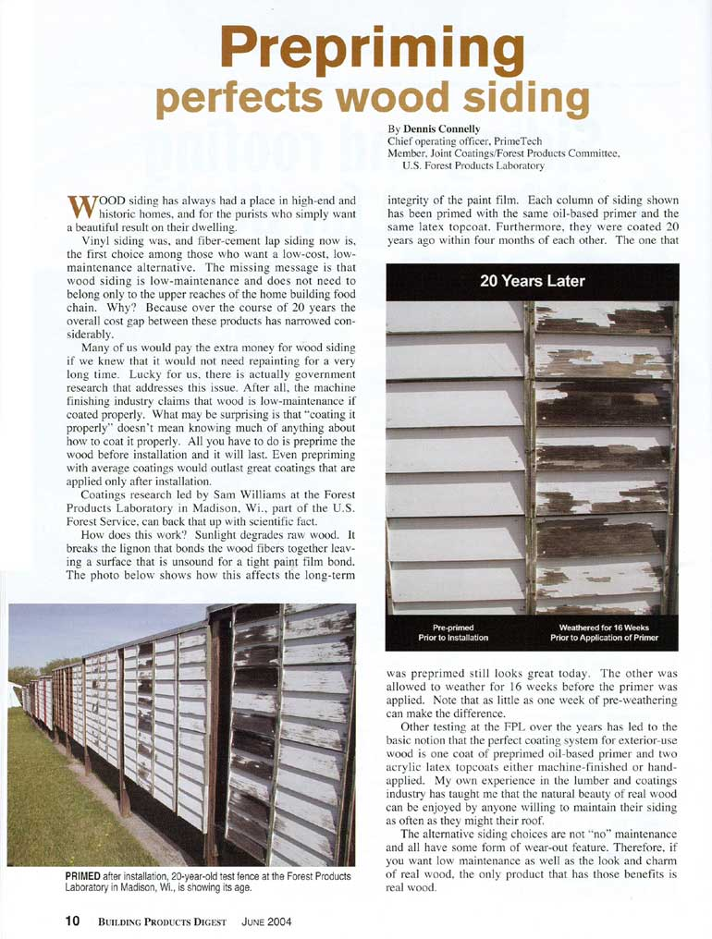

Visit us at: www.GoPrimTECH.com or call: (800) 458-5775

